

|  |  |
| --- | --- |
| STUDENTS | * Salman Hussain (1490660) * Nawab Zada (1488972) * Vayun Danicha (1490146) * Talha (1490586) |
| FACULTY | Muneeb Farhan |
| BATCH | 2305E |
| SEMESTER | 1st Semester |

**Index**

1. Introduction
2. Objectives
3. Problem Statement
4. Hardware/Software Requirements
5. Home Page
6. About Us
7. Bathroom Mirrors
8. Dressing Mirrors
9. Bedroom Mirrors
10. Drawing Mirrors
11. Contact Us
12. Task Sheet
13. Sitemap

**Introduction**

The thirst for learning, upgrading technical skills and applying the concepts in real life environment at a fast pace is what the industry demands from IT professionals today. However busy work schedules, far-flung locations, unavailability of convenient time-slots pose as major barriers when it comes to applying the concepts into realism. And hence the need to look out for alternative means of implementation in the form of laddered approach.

The above truly pose as constraints especially for our students too! With their busy schedules, it is indeed difficult for our students to keep up with the genuine and constant need for integrated application which can be seen live especially so in the field of IT education where technology can change on the spur of a moment. *Well, technology does come to our rescue at such times!!*

Keeping the above in mind and in tune with our constant endeavour to use Technology in our training model, we at Aptech have thought of revolutionizing the way our students learn and implement the concepts using tools themselves by providing a *live and synchronous eProject learning environment!*

**So what is this eProject?**

eProject is a step-by-step learning environment that closely simulates the classroom and Lab based learning environment into actual implementation. It is a project implementation at your fingertips!! An electronic, live juncture on the machine that allows you to

* Practice step by step i.e. laddered approach.
* Build a larger more robust application.
* Usage of certain utilities in applications designed by user.
* Single program to unified code leading to a complete application.
* Learn implementation of concepts in a phased manner.
* Enhance skills and add value.
* Work on real life projects.
* Give a real life scenario and help to create applications more complicated and useful.
* Mentoring through email support.

The students at the centre are expected to complete this eProject and send complete project along with the documentation to eProjects Team

Looking forward to a positive response from your end!!

**Objectives of the project**

The Objective of this program is to give a sample project to work on real life projects. These applications help you build a larger more robust application.

The objective is not to teach you HTML/JavaScript/Dreamweaver/HTML5 but to provide you with a real life scenario and help you create basic applications using the tools.

You can revise the chapters before you start with the project.

This project is meant for students who have completed the module of ***Dreamweaver***. These programs should be done in the Lab sessions with assistance of the faculty if required.

It is very essential that a student has a clear understanding of the subject. Students should go through the project and solve the assignments as per requirements given.

Kindly get back to eProjects Team in case of any doubts regarding the application or its objectives.

**Problem Statement**

***Clear Reflections*** is an organization selling mirrors. They sell varieties of mirrors of different types suiting every requirement and into various sizes/shapes, starting from office to home and etc.

You are supposed to create a website for them with the below mentioned requirement specifications.

The website is to be developed for the Windows Platform using HTML5, JavaScript and Geolocation. The site should work well in all leading browsers including Chrome, IE, Firefox etc.

**Requirement Specification:**

The Web site is to be created based on the following requirements.

1. The Home Page should be created making use of Sections with a suitable logo, the header section can be added which will show images chairs.
2. The site must contain the links to navigate through any category for the information.
3. The site should display a menu which will contain the options for brief introduction about the various mirrors available, location of the shop and any other information if required.
4. The information should be categorized according to the type of the mirrors like if a User wants to see only “drawing room mirrors” or any other category chairs then he/she can click on a Link/button/menu etc and can see only that type mirror.
5. A brief summary of about the mirrors should be displayed on the Web Page along with the picture but detailed Features should be stored in Individual Word documents which can be downloaded or viewed by the User who wishes to see the same.
6. The sample categories can be
   * Drawing/Living room mirrors
   * Bathroom mirrors
   * Dressing mirrors
   * Bedroom mirrors
   * ….user can add categories of their own choice too.
7. There should also be categorization depending on material like
   * Wooden framed
   * Acrylic bordered
   * Metal bordered
   * Decorative mirrors
   * LED mirrors
   * Bluetooth mirrors
8. There should be a “Contact Us” page which will have the Address of the Company which should be displayed using GeoLocation API (eg. GoogleMaps) and the email address which when clicked will invoke the local mail client from where they can send an email.

**Hardware/ Software Requirements**

**Hardware**

* A minimum computer system that will help you access all the tools in the courses is a Pentium 166 or better
* 64 Megabytes of RAM or better

**Software *[Either or Combination as per Course/Sem]***

* Notepad/HTML editor/CoffeeCup
* Angular / Angular JS / React / BootStrap
* Dreamweaver / Figma
* MS IE / Chrome / FireFox / Netscape /MS Edge

**CLEAR REFLECTIONS**

**Home Page:**

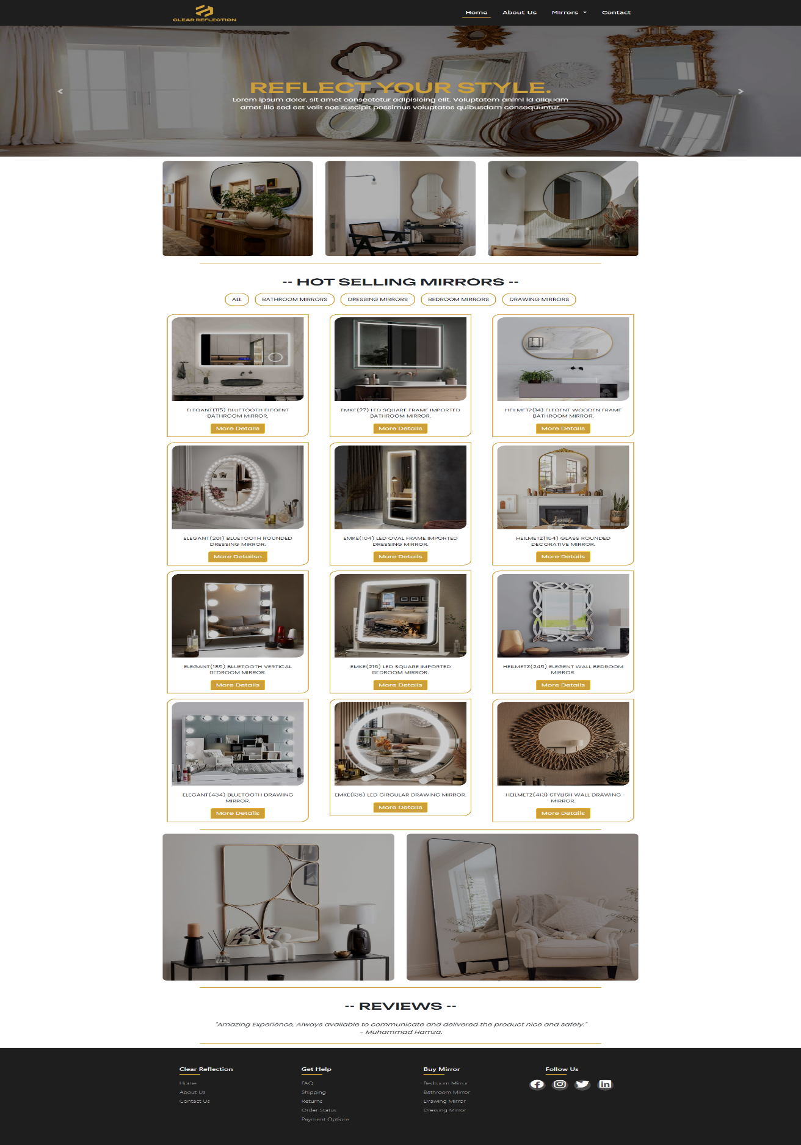

­­

**CLEAR REFLECTIONS**

**About Us:**

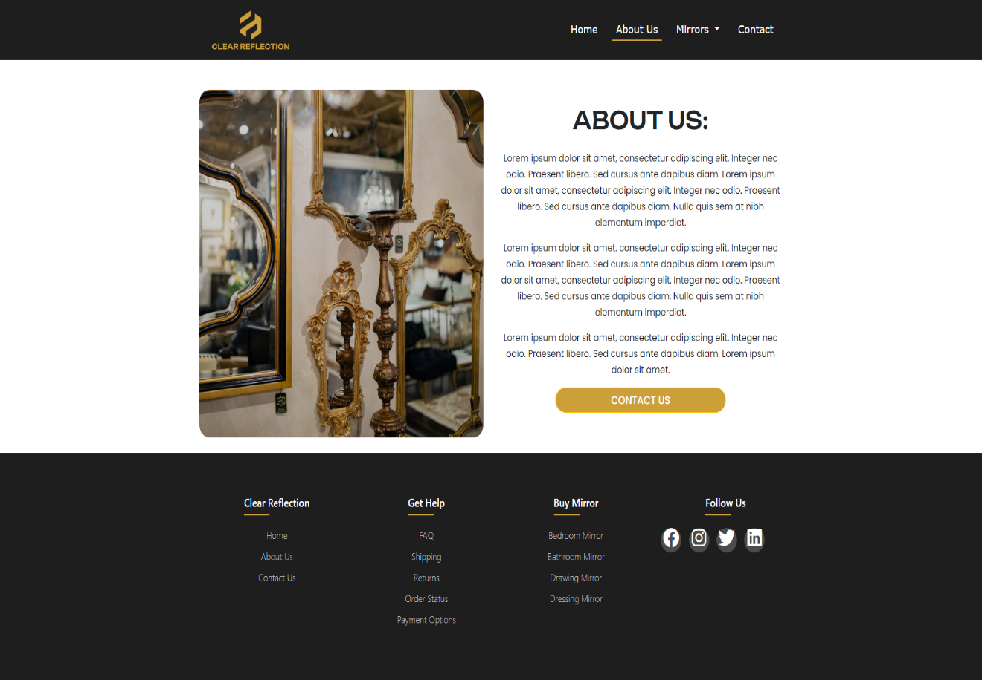

**CLEAR REFLECTIONS**

**Bathroom Mirrors:**

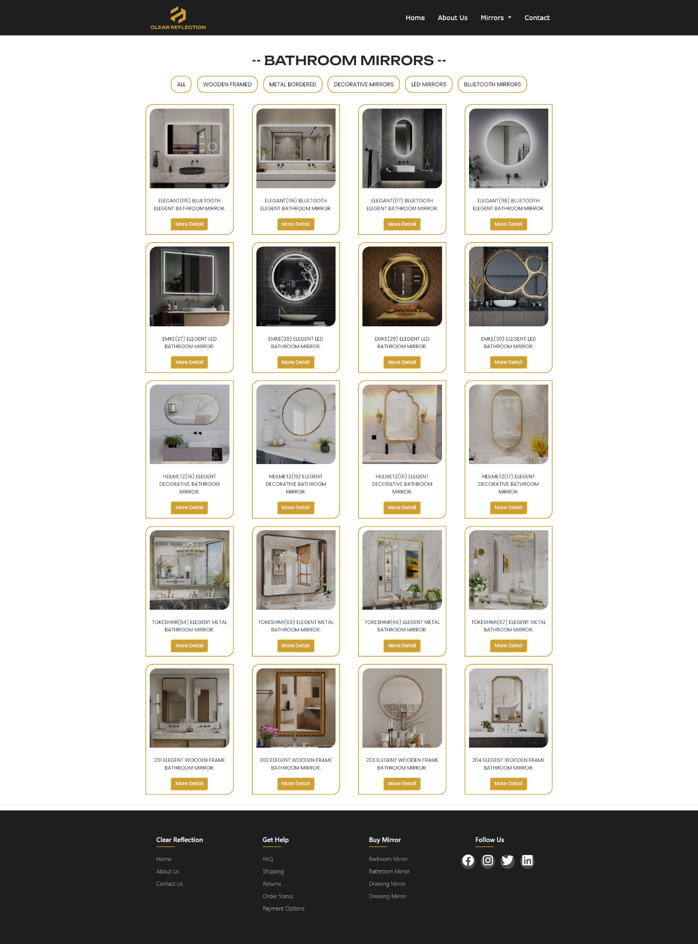

**CLEAR REFLECTIONS**

**Dressing Mirrors:**

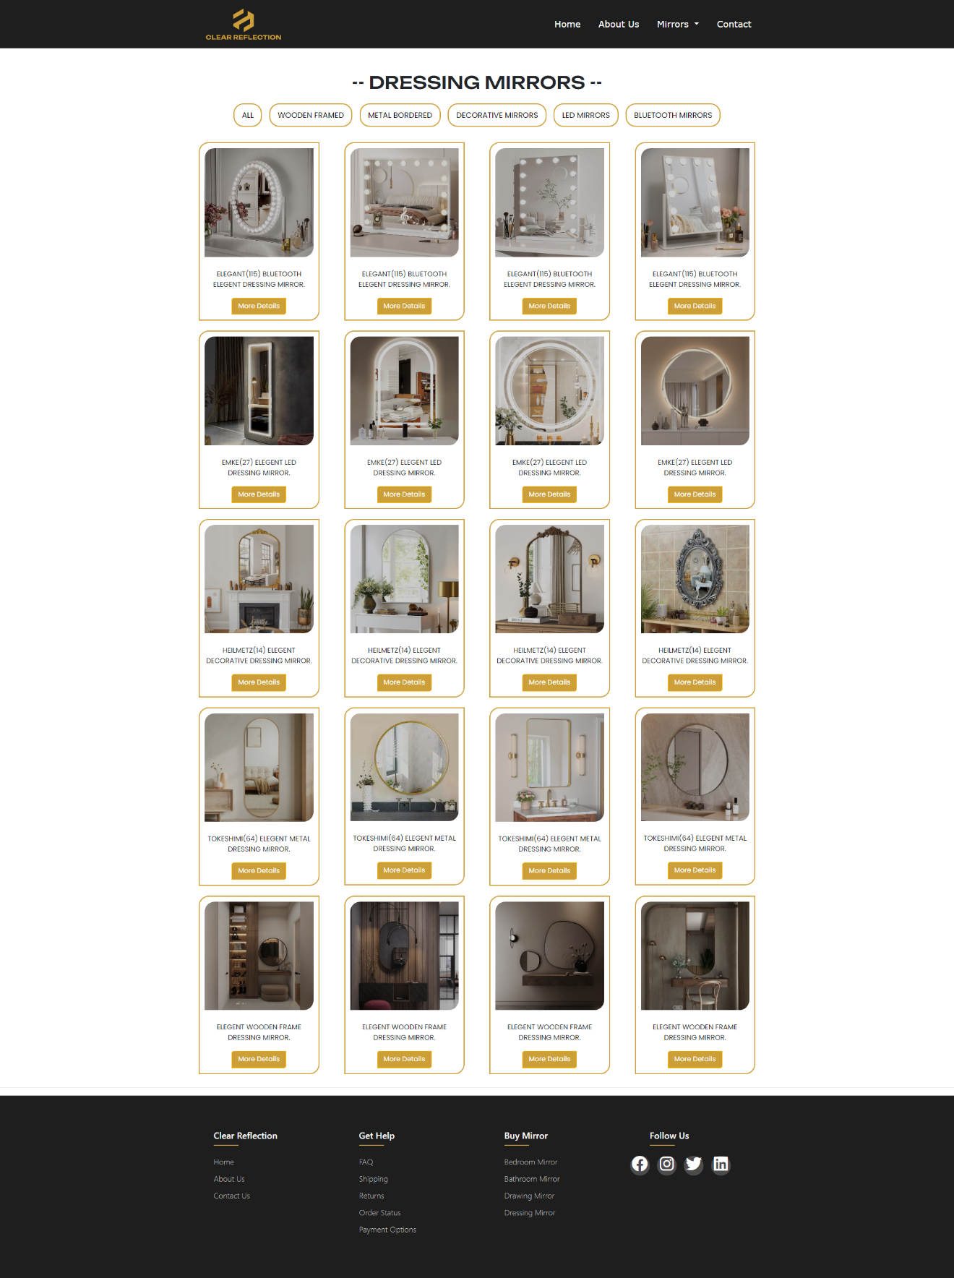

**CLEAR REFLECTIONS**

**Bedroom Mirrors:**

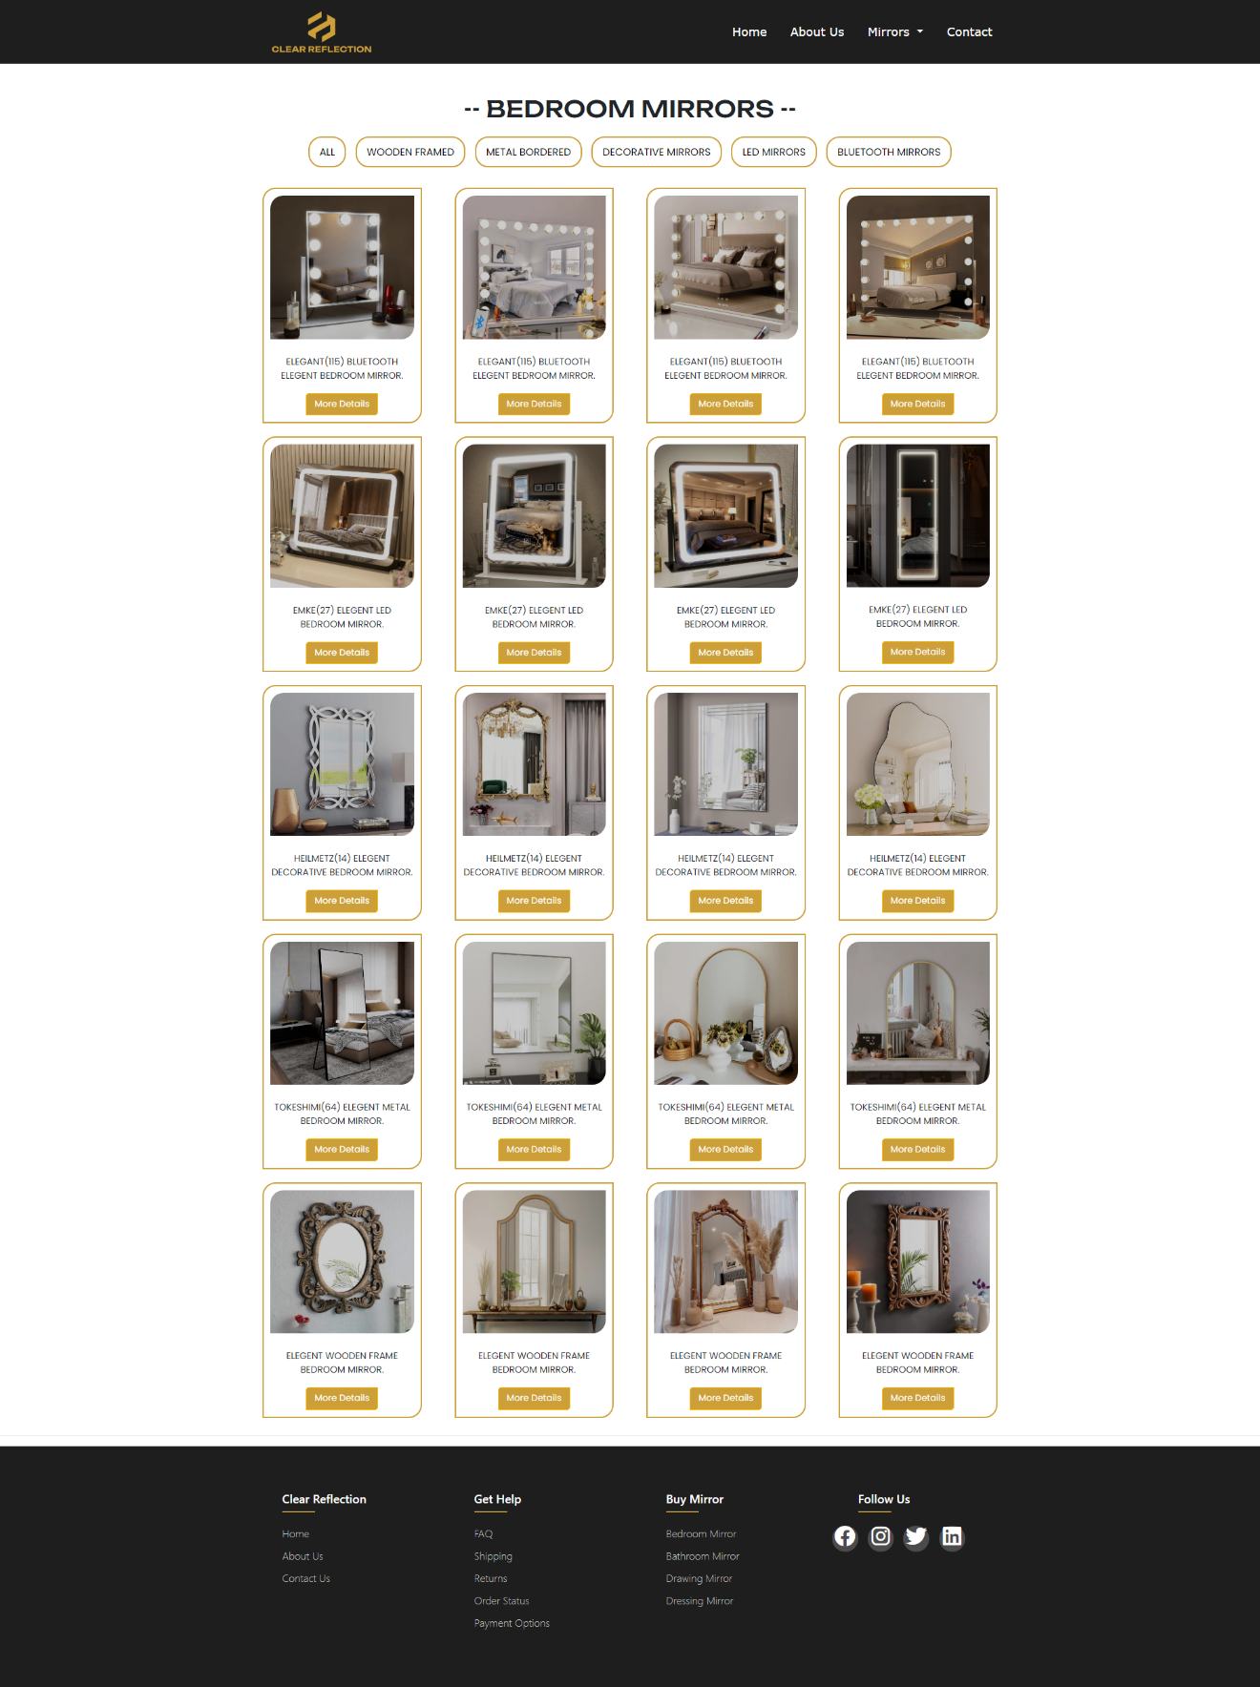

**CLEAR REFLECTIONS**

**Drawing Mirrors:**

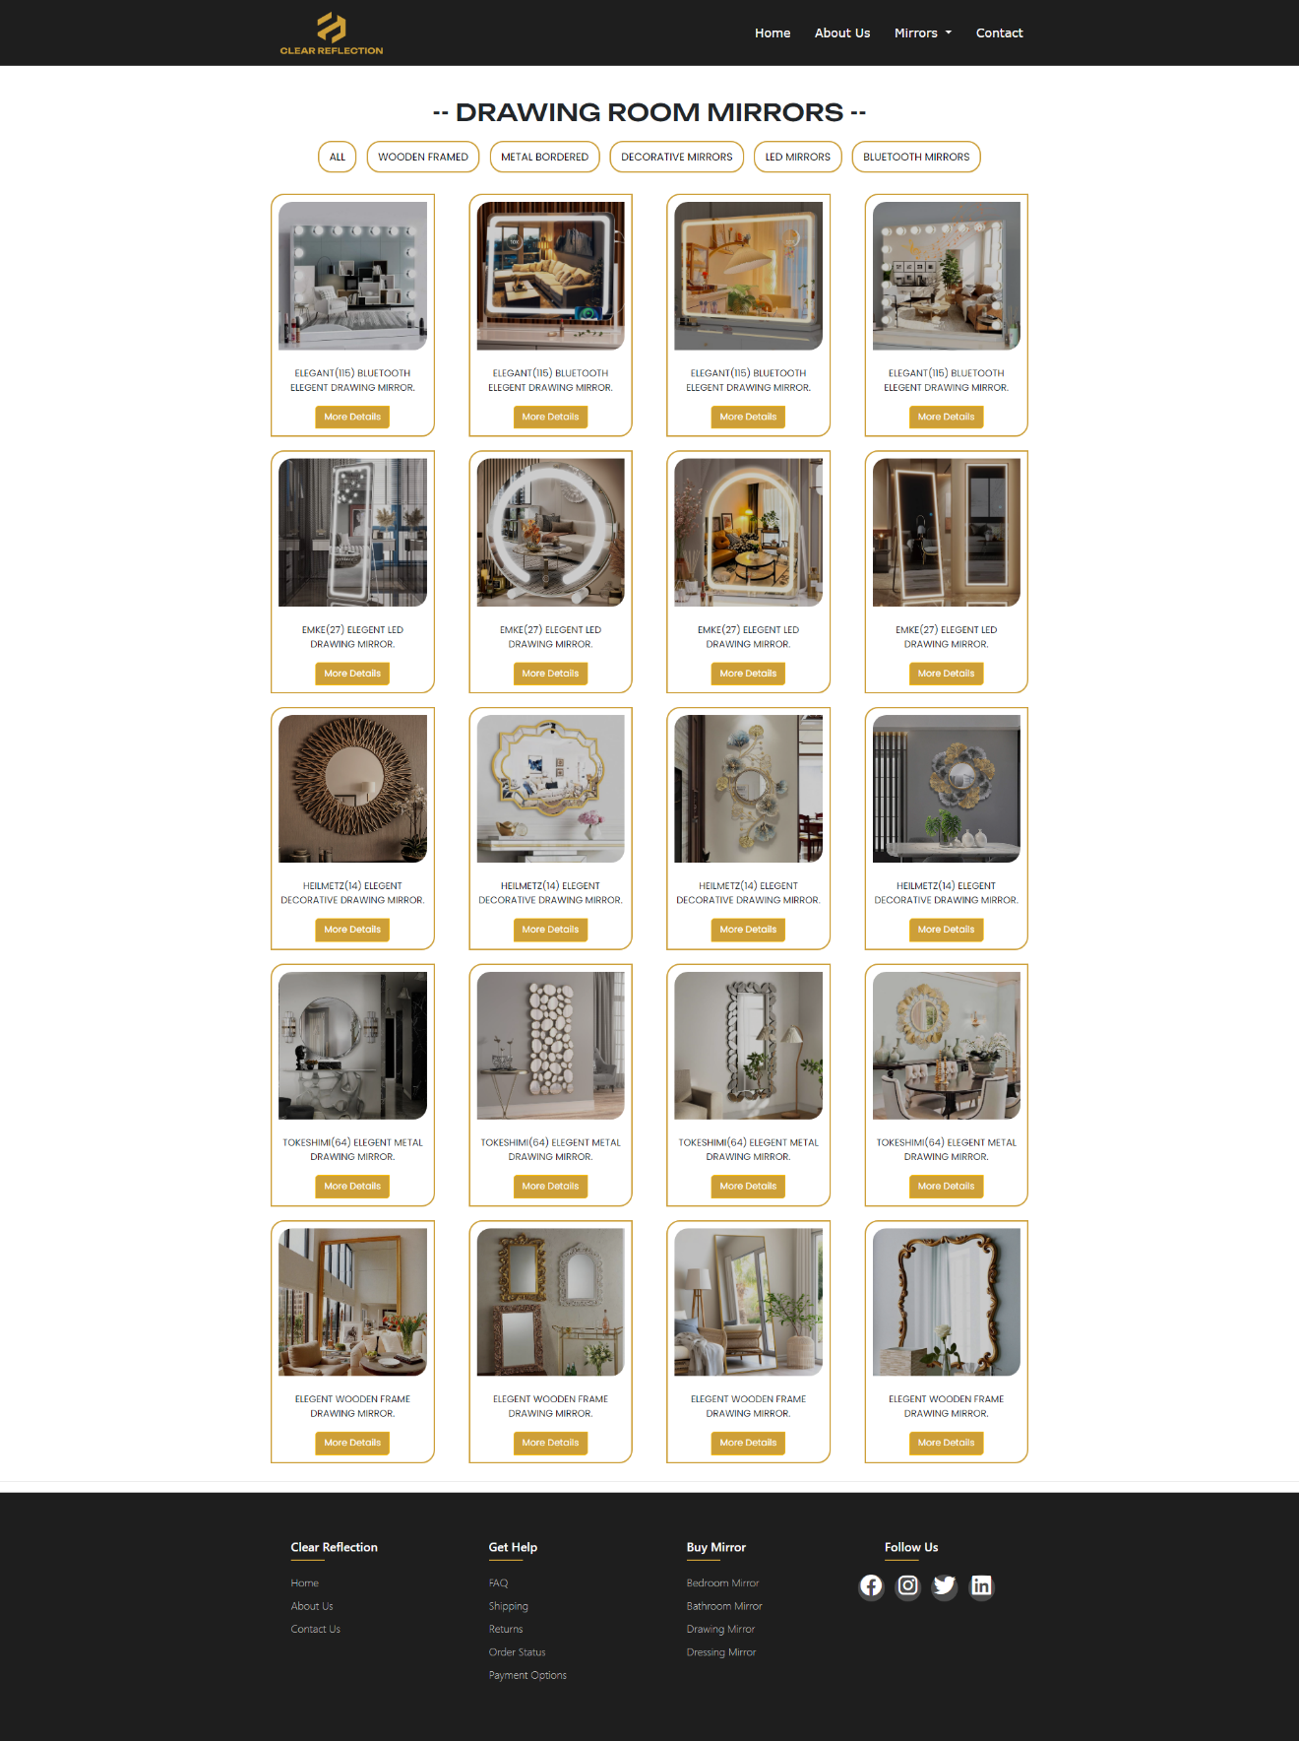

**CLEAR REFLECTIONS**

**Product Details:**

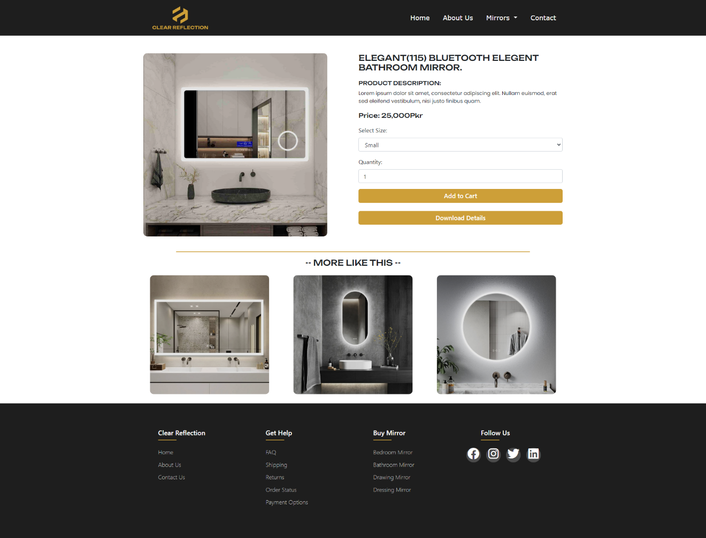

**CLEAR REFLECTIONS**

**Contact Us:**

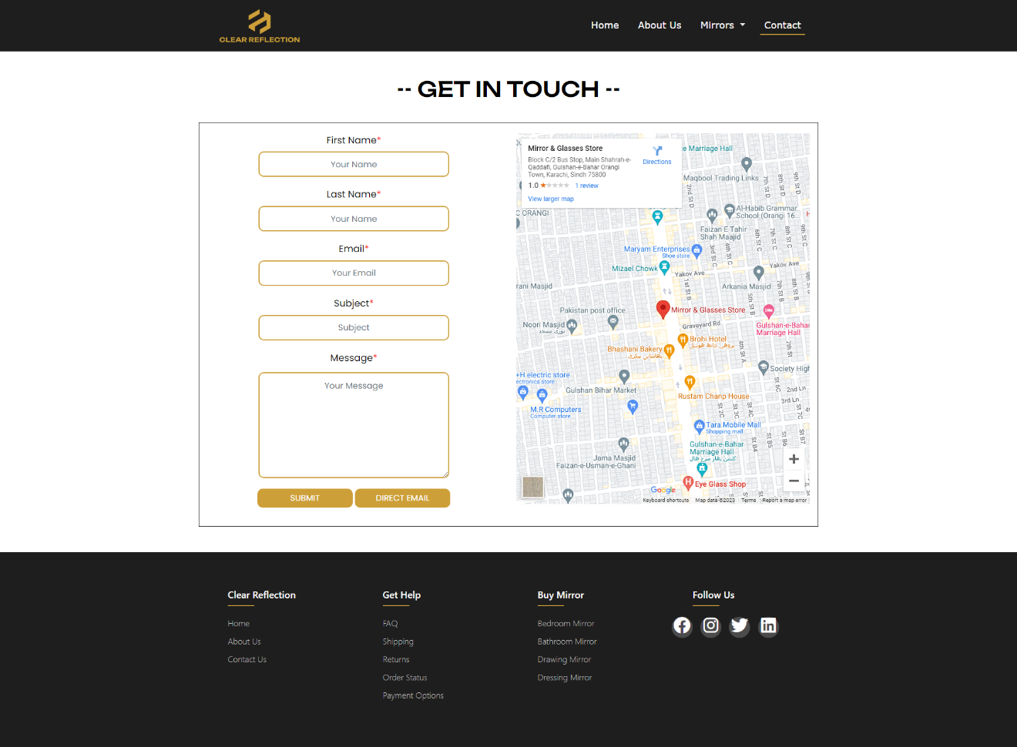

**TASK SHEET**

|  |  |  |
| --- | --- | --- |
| TASKS | DAYS | MEMBER WORK |
| Navbar / Footer | 2 Days | Vayun and Nawab Zada |
| Home Page | 6 Days | Vayun, Salman, Nawab Zada and Talha |
| About Us | 2 Days | Vayun |
| Mirrors | 7 Days | Salman |
| Contact Us | 2 Days | Nawab Zada |
| Documentation | 1 Day | Talha and Salman |
| Presentation | 1 Day | Vayun, Salman, Nawab Zada and Talha |

**SITEMAP**

CLEAR

REFLECTIONS